1.- Define the difference between html doctype tag and html tag. Please notice that it is better style to include the html tag in addition to the html doctype tag.

The **DOCTYPE tag** tells the browser which version of html you are using, meanwhile, the **HTML tag** tells the browser it is an HTML document, reprensents the root of an HTML document and it is the container of all other HTML elements.

2.- Analyze the attached HTML pages corresponding to Figure 3.1, 3.17 of Deitel & Deitel's Chapter 3. These pages use the new HTML5 input types: color, date, datetime, email, number, range, etc. and new attributes. Review how these input types are used. Select three of them and explain how they are used.

**URL:** The user has to fill the field of the form with an URL

**Week:** The user needs to fill the field with a year and add the number of the week

**Range:** The user needs to choose a number between a start and end value

3.- Load these pages in several browsers, such as Google Chrome, Firefox, Safari, Internet Explorer or Edge. Add the corresponding images to a word document. Are all new elements displayed in the same way in the different browsers? Explain.

**Google Chrome :**

The input fields actually work and there is autocomplete available.

Meanwhile, in the .jpg and .png images the background appears all black.

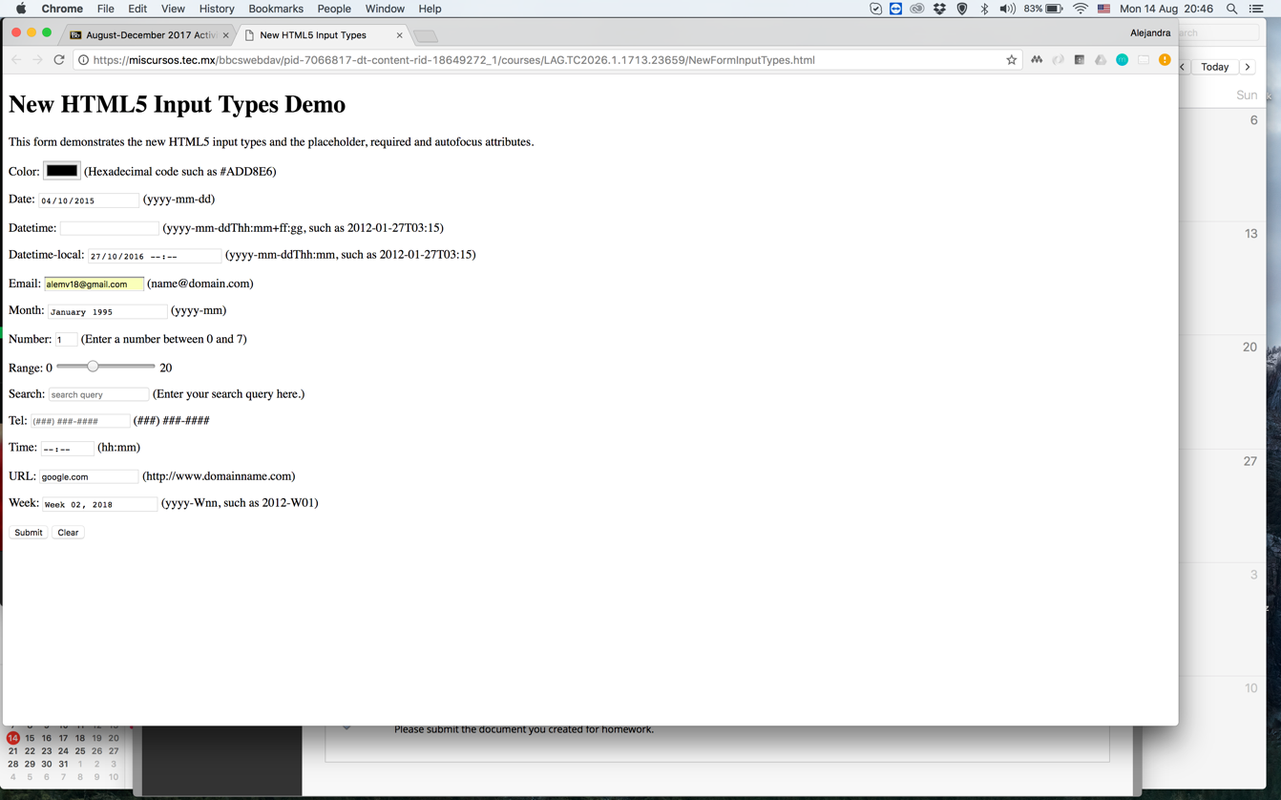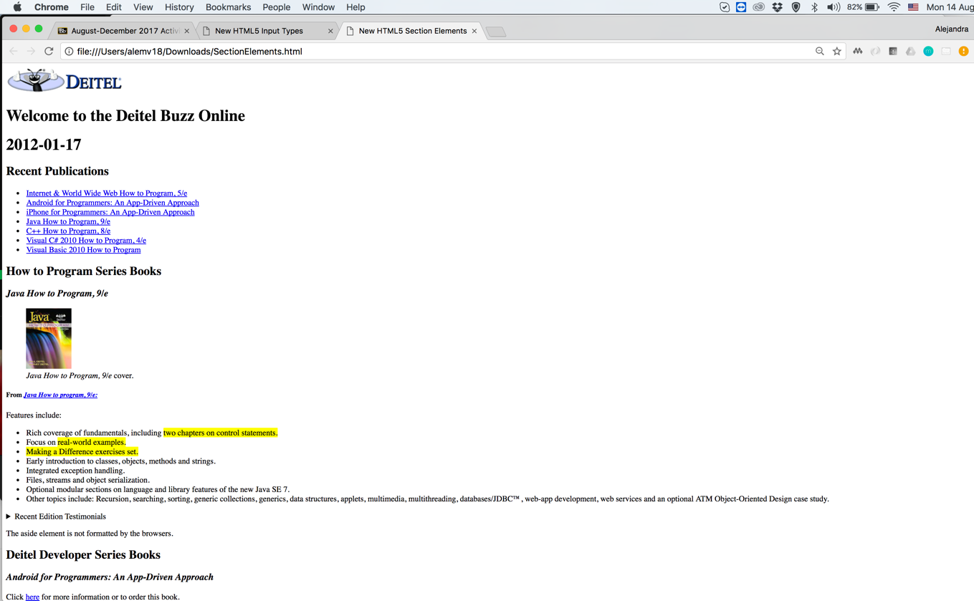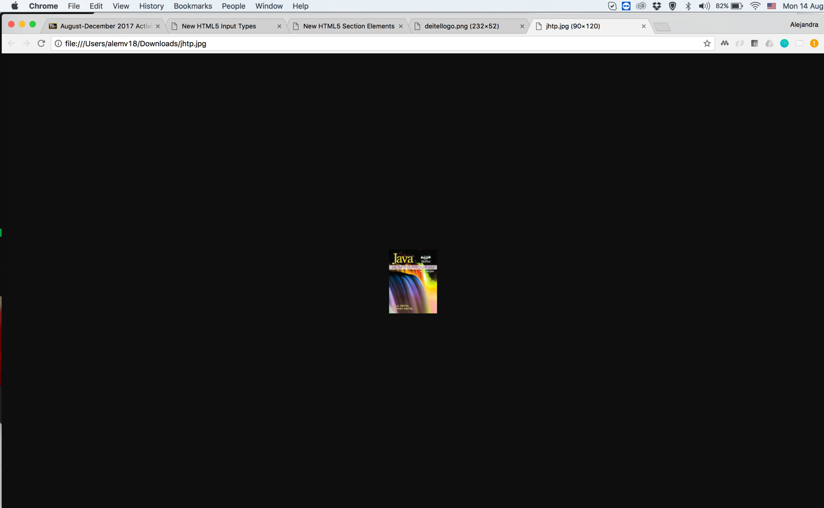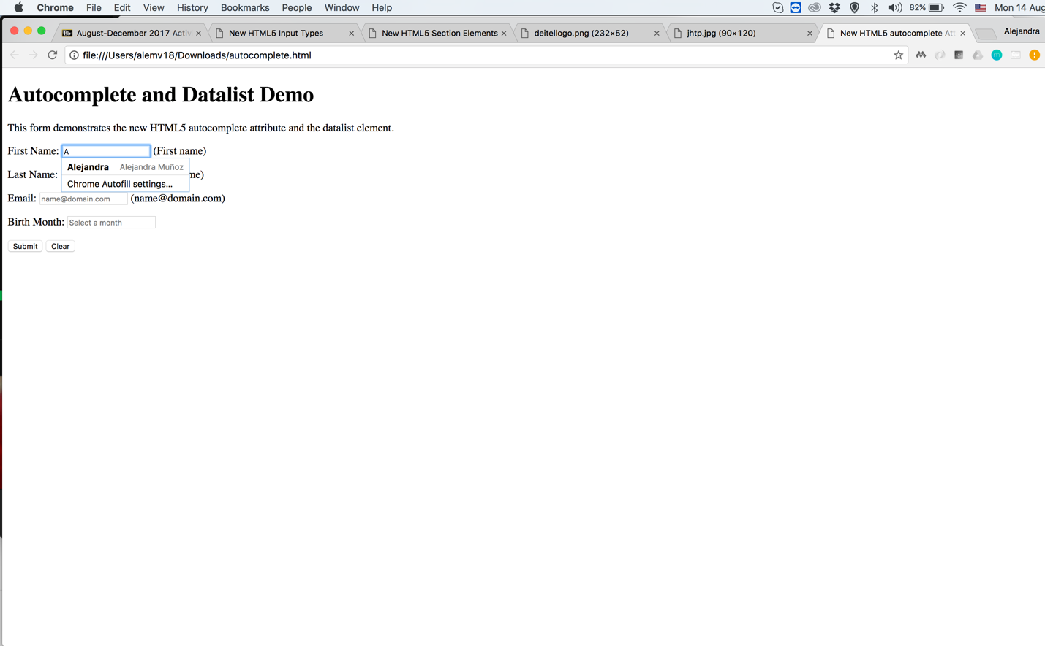

**Firefox:**

The new input fields of HTML5 doesn’t work, just the color field

The .jpg and .png images appear with black background and center of the browser

The autocomplete doesn’t work

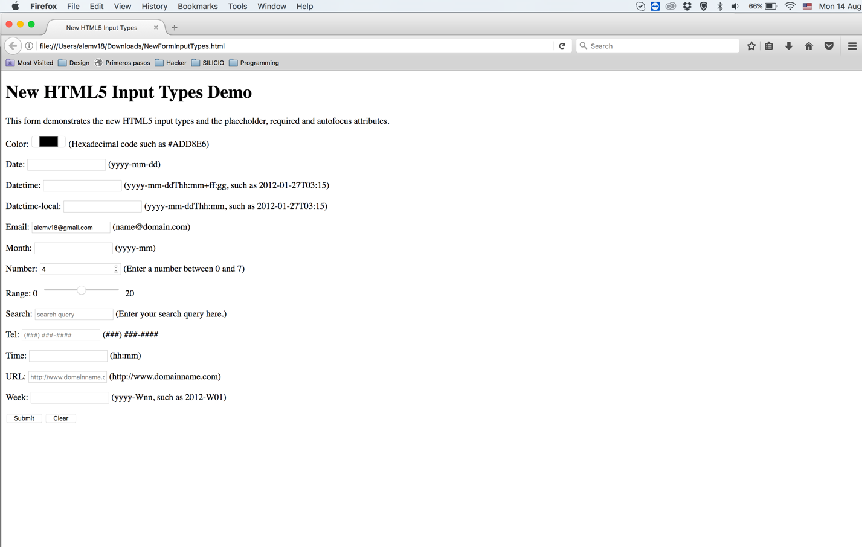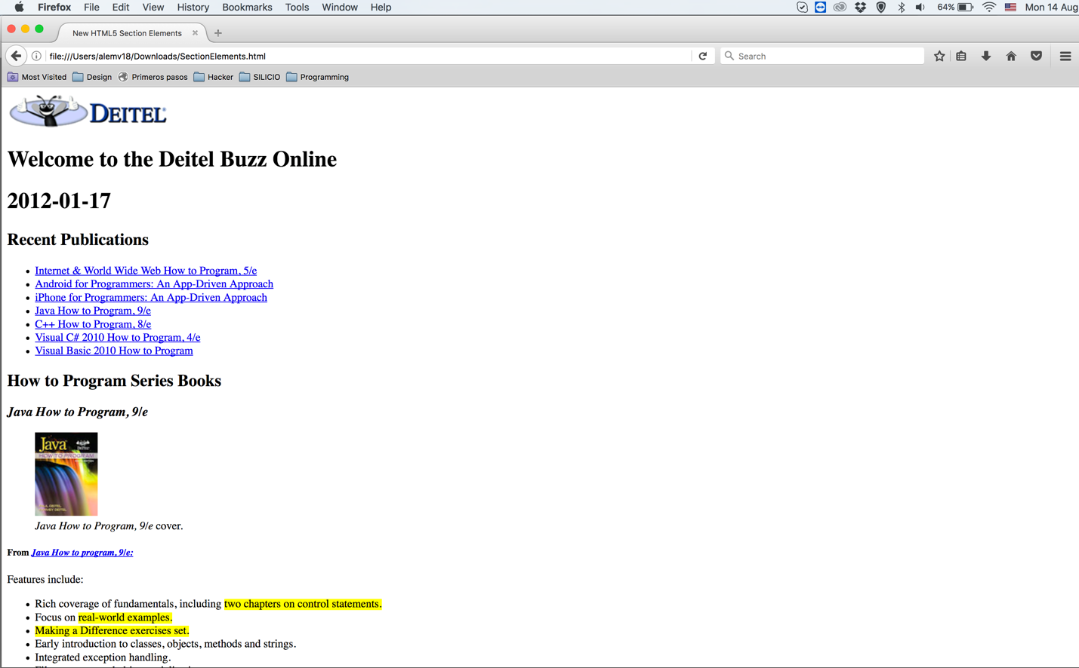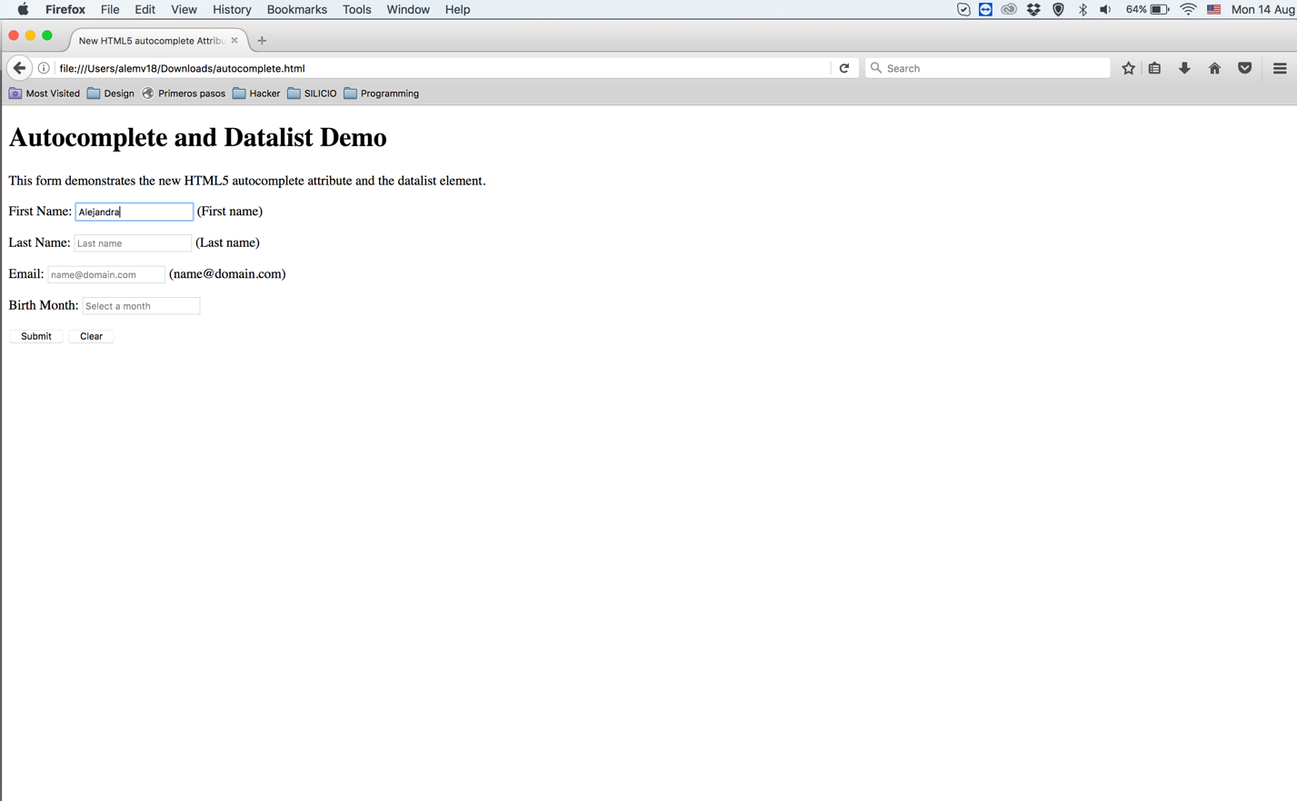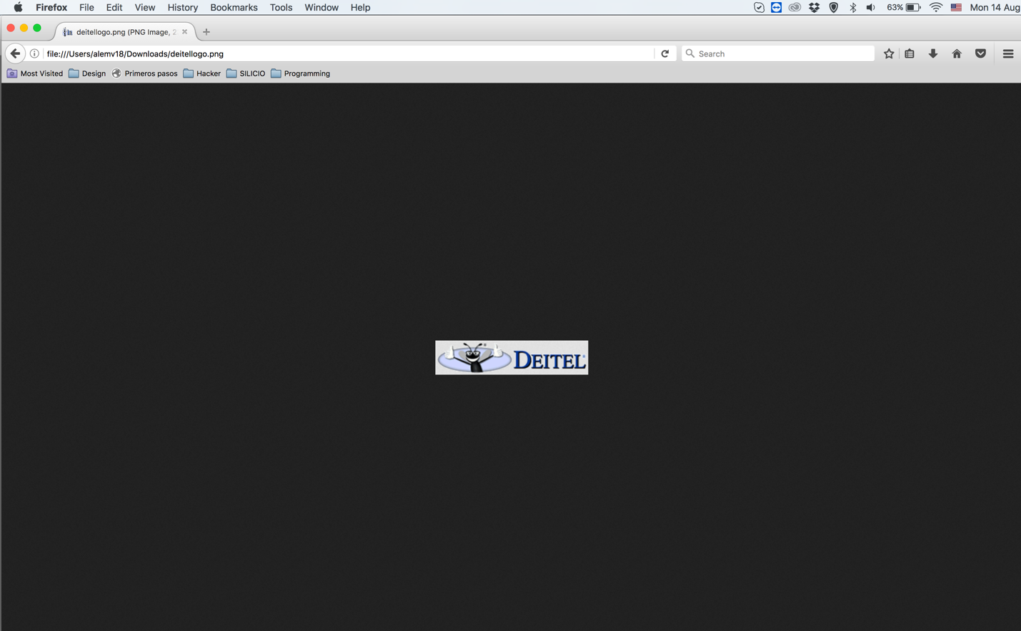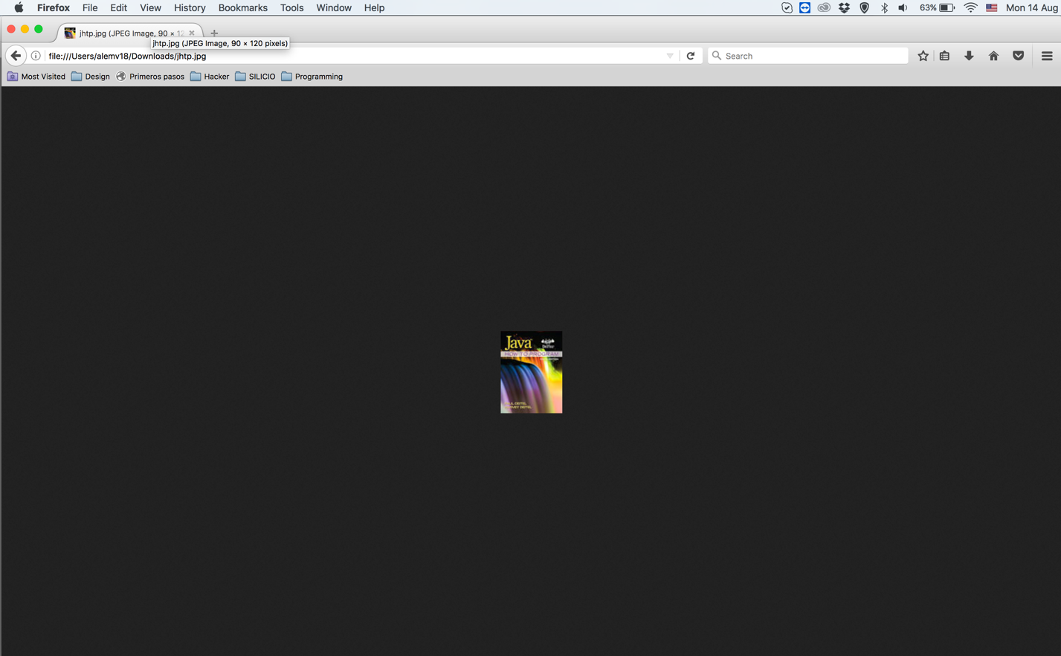

**Safari:**

The input field doesn’t work as well, the arrows do not appear.

On the images they appear on the top with white background.

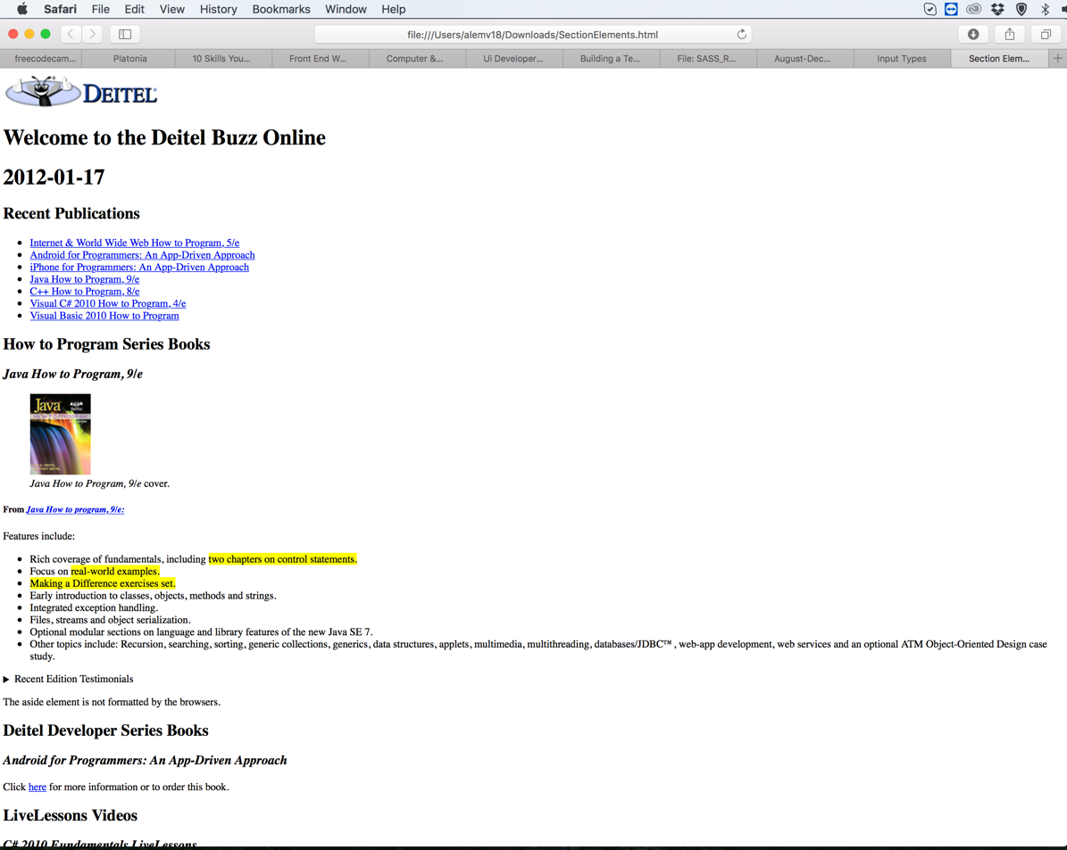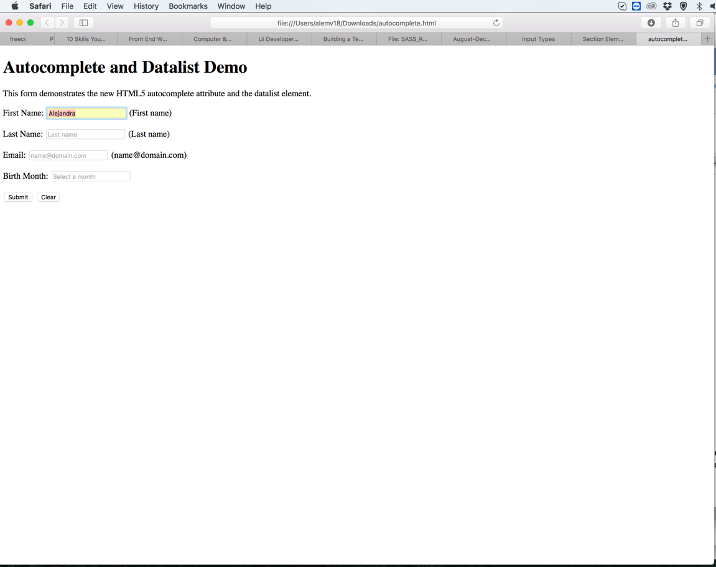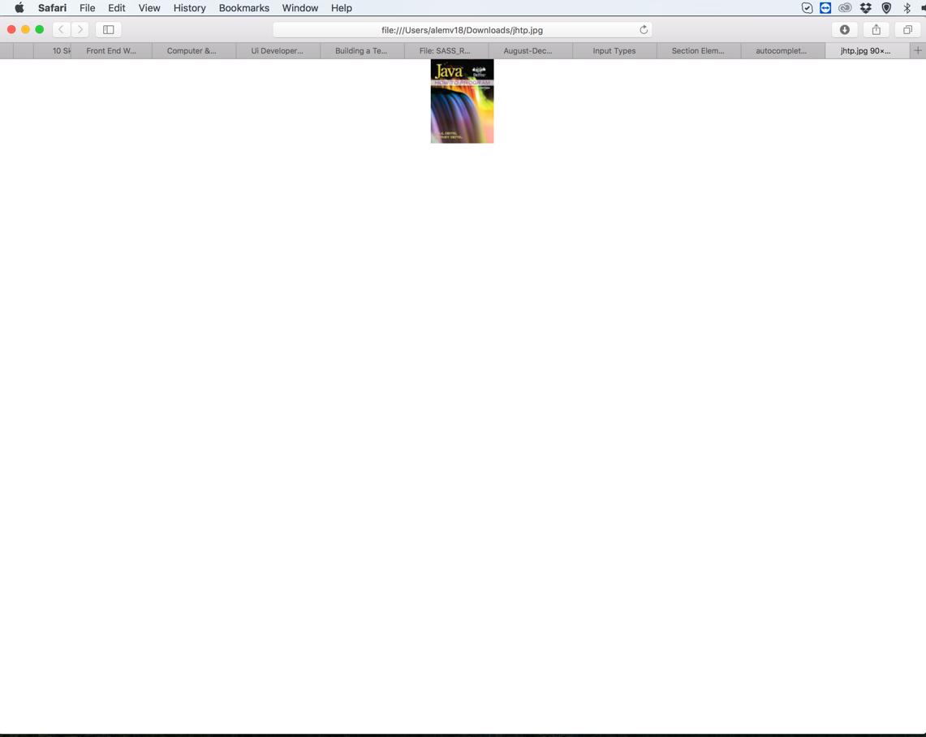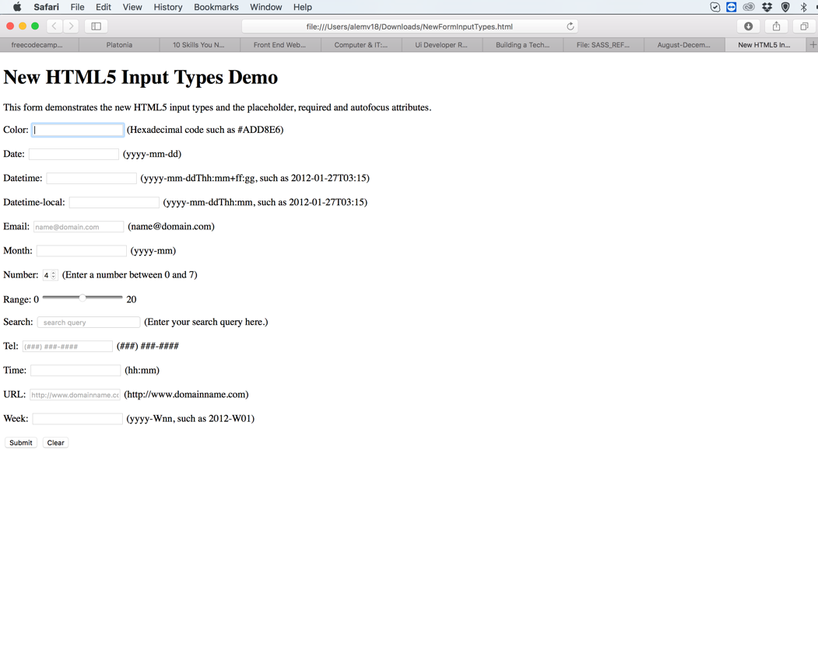

**Internet Explorer**

**Internet Edge**